Deterministic Design of Kinematic Coupling
The deterministic design of Kinematic Coupling started by laying out the functional requirements and completing the whole design cycle. For the kinematic coupling that we were supposed to make this week, time and budget constraints were big influencers in determining the design which was selected for fabrication. However, the coupling was functional and was able to bear reasonable loads and moments. Stiffness, accuracy and repeatability were other functional requirements which were taken into consideration.
FRDPARRC
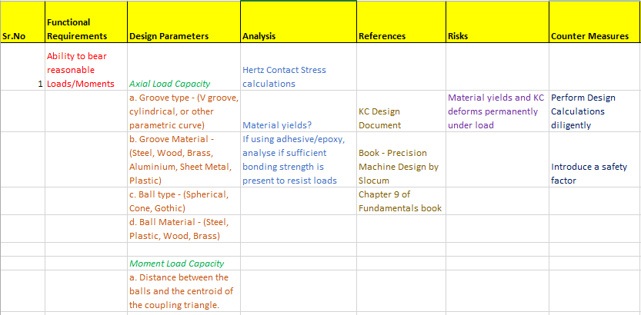
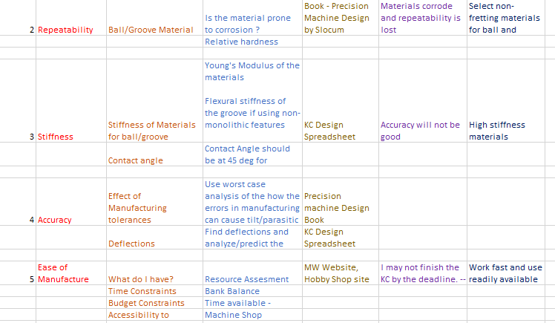

Concept Generation
Various concepts for the design of the kinematic coupling were generated as below:
Groove Concept Designs:
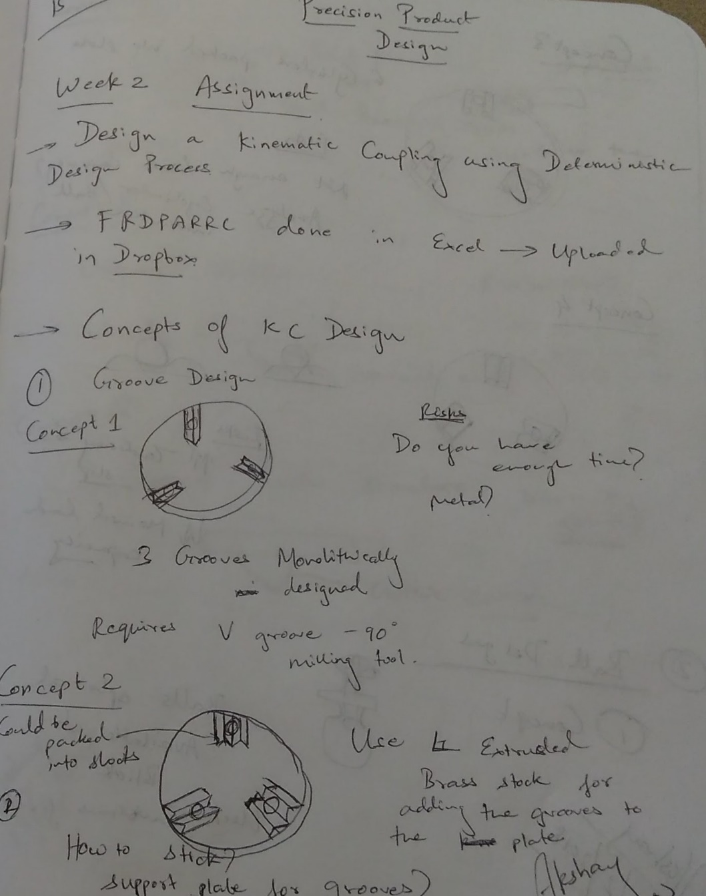
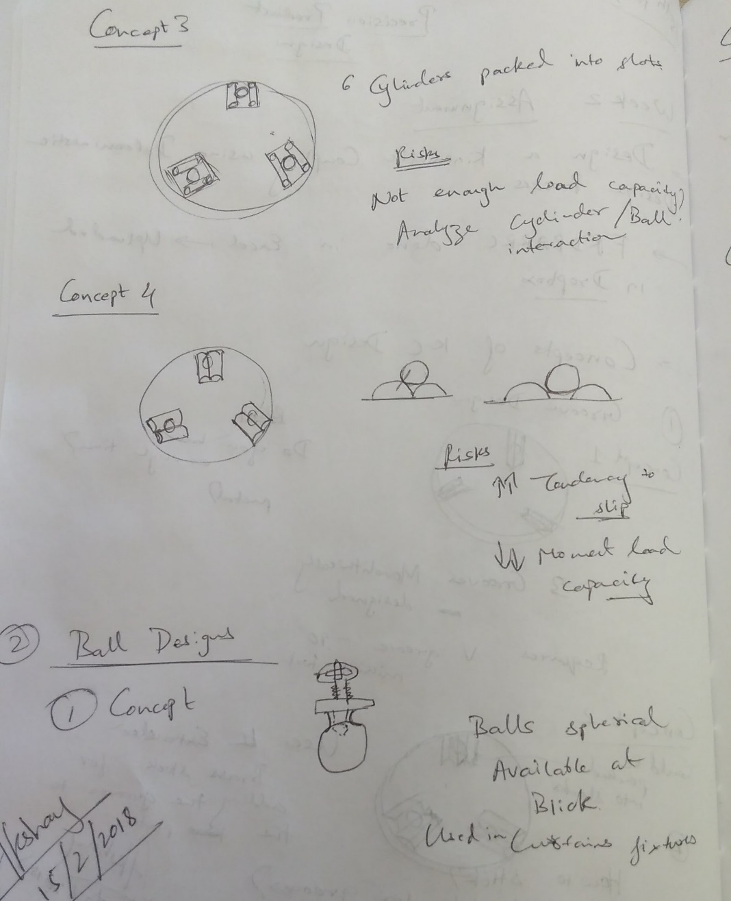

Ball Concept Designs:
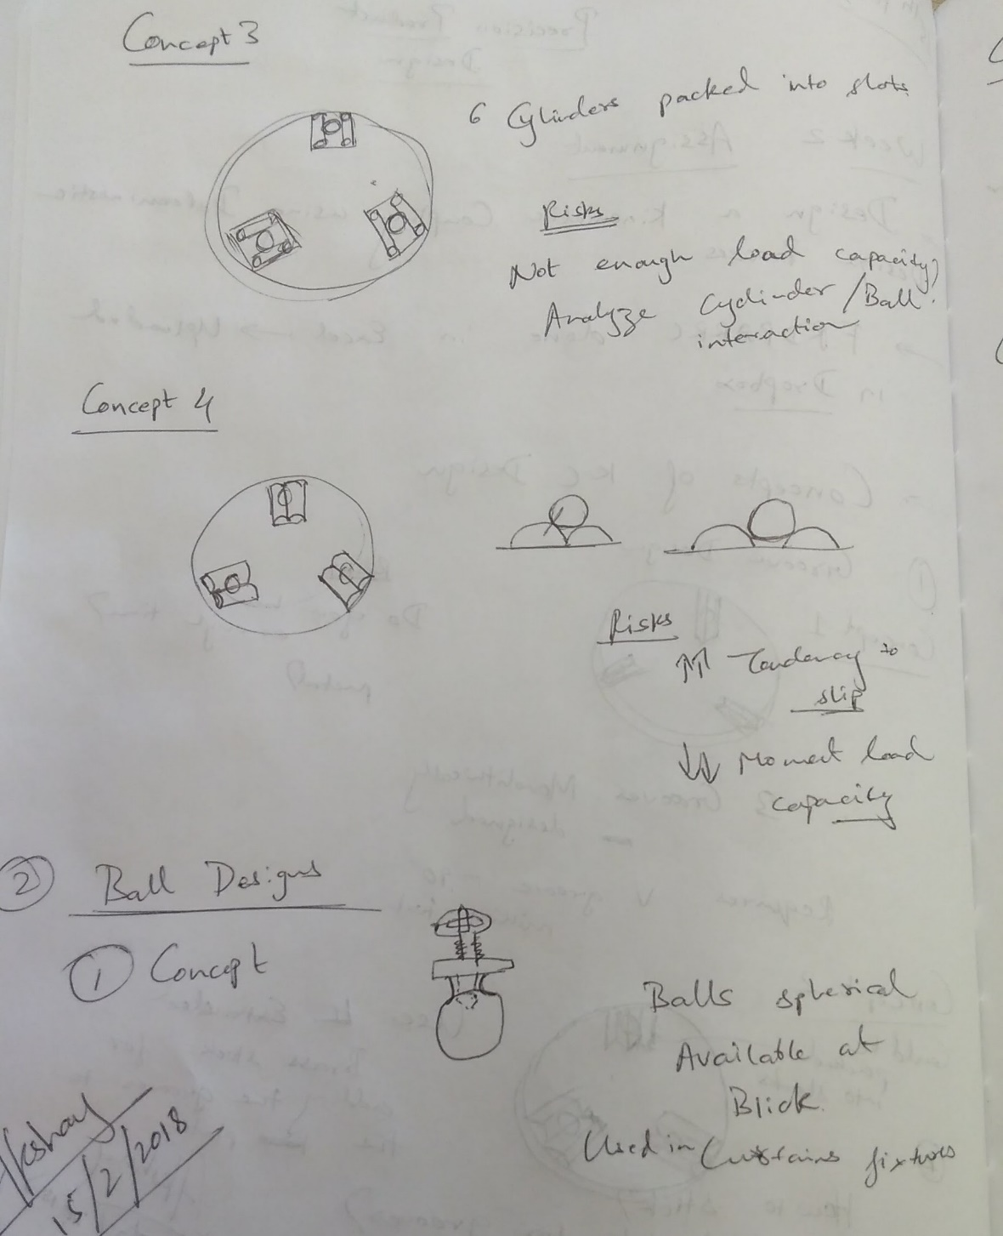
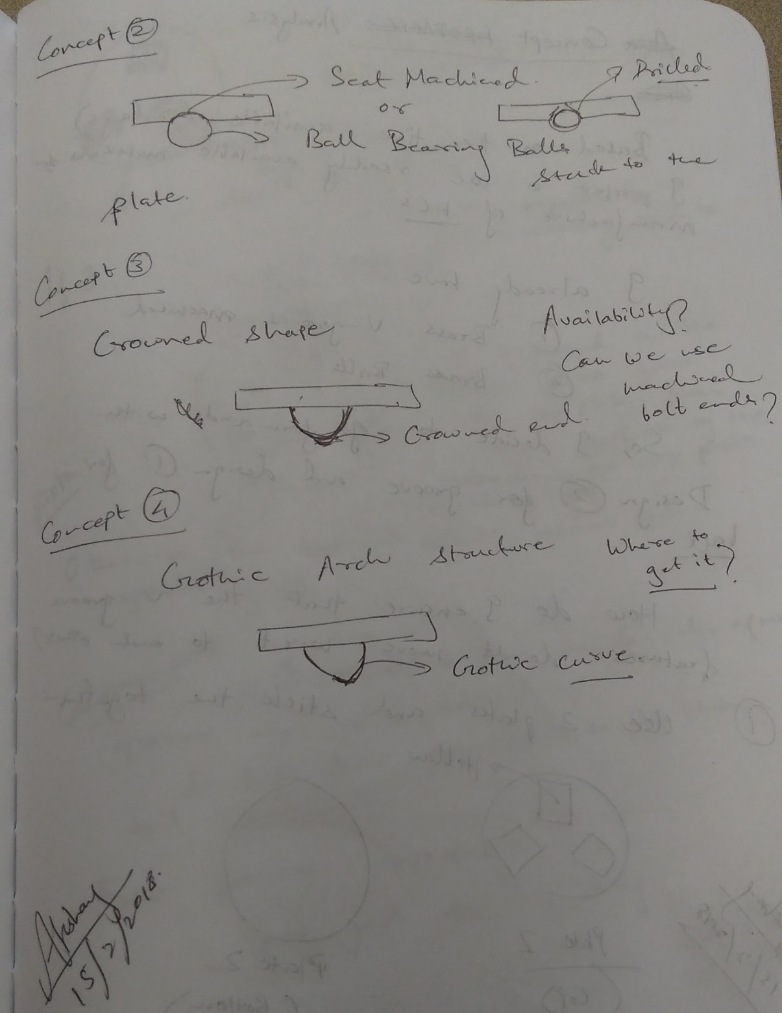
Choice of Concept:
The final concept which seemed to be the best way forward was concept 2 of the groove and concept 1 for the ball. The critical factor which tilted the balance in the favour of these concepts was ease of manufacturing and the availability of components required for the fabrication. I already had extruded brass stock with which I could easily manufacture the groves and I bought the balls (which were actually lamp fittings) from a hardware store nearby. Both these components happened to match perfectly in terms of relative dimensions. This ensured that the contact stress zone will not be near to the edges.

Analysis:
Using the Hertz Contact theory, I did few calculations on the stiffness, accuracy and load capacity of the kinematic coupling.
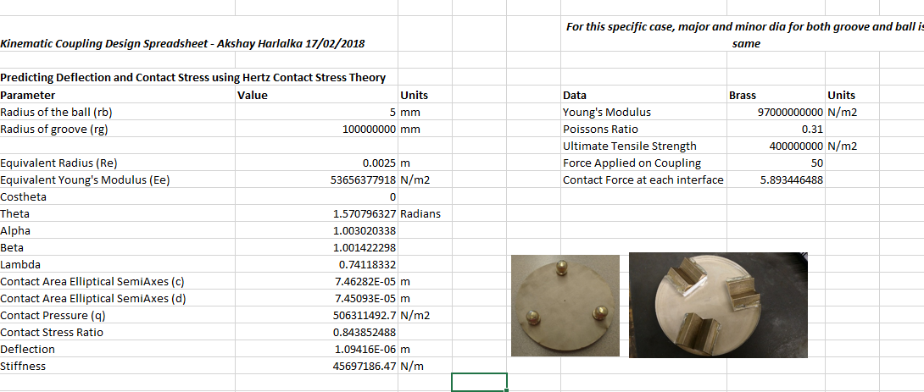

For an external load of 20 N, I predicted a deflection of 0.594 um whereas for 50 N, it was 1.094 um.
The max load capacity for this coupling was 83 N.
The stiffness was predicted to be 33.6 N/um at 20 N load. The stiffness increased as the load applied on the coupling increased.
The size of the contact zone is 54 um for the 20 N load. The edges of the groove inserts are more than 5 times the contact zone diameter away so, the Saint Venant’s principle is not violated!

CAD Model
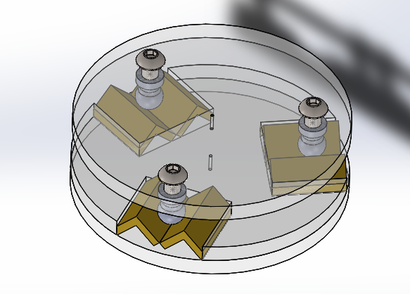
Manufacturing Drawings
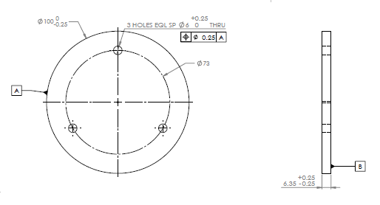
Manufacturing Drawing of the Top Plate
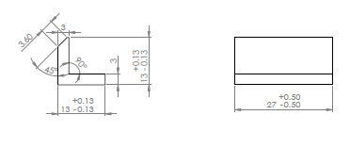
Manufacturing Drawing of the Grooves
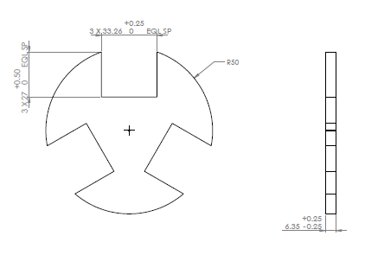
Manufacturing Drawing of the Slotted Plate
Fabrication – Picture Flow
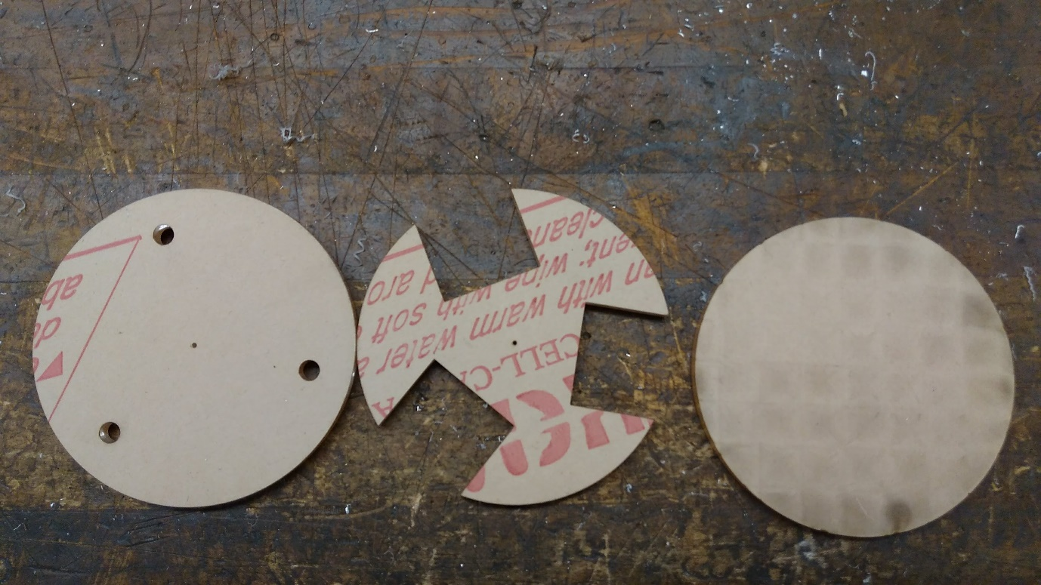
Laser Cutting of ¼ ‘’ Acrylic Sheet
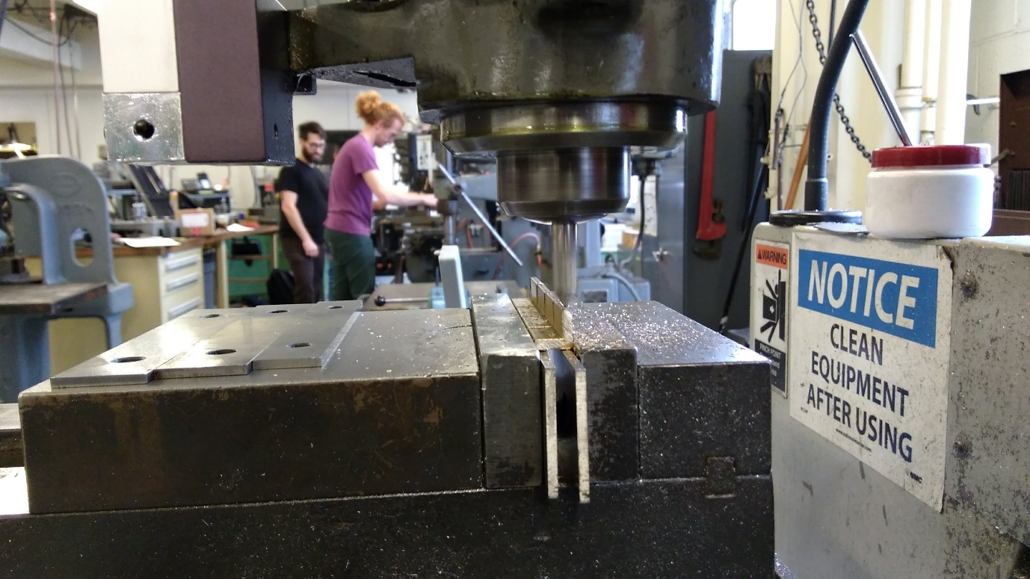
Chamfering the edges of the brass grooves
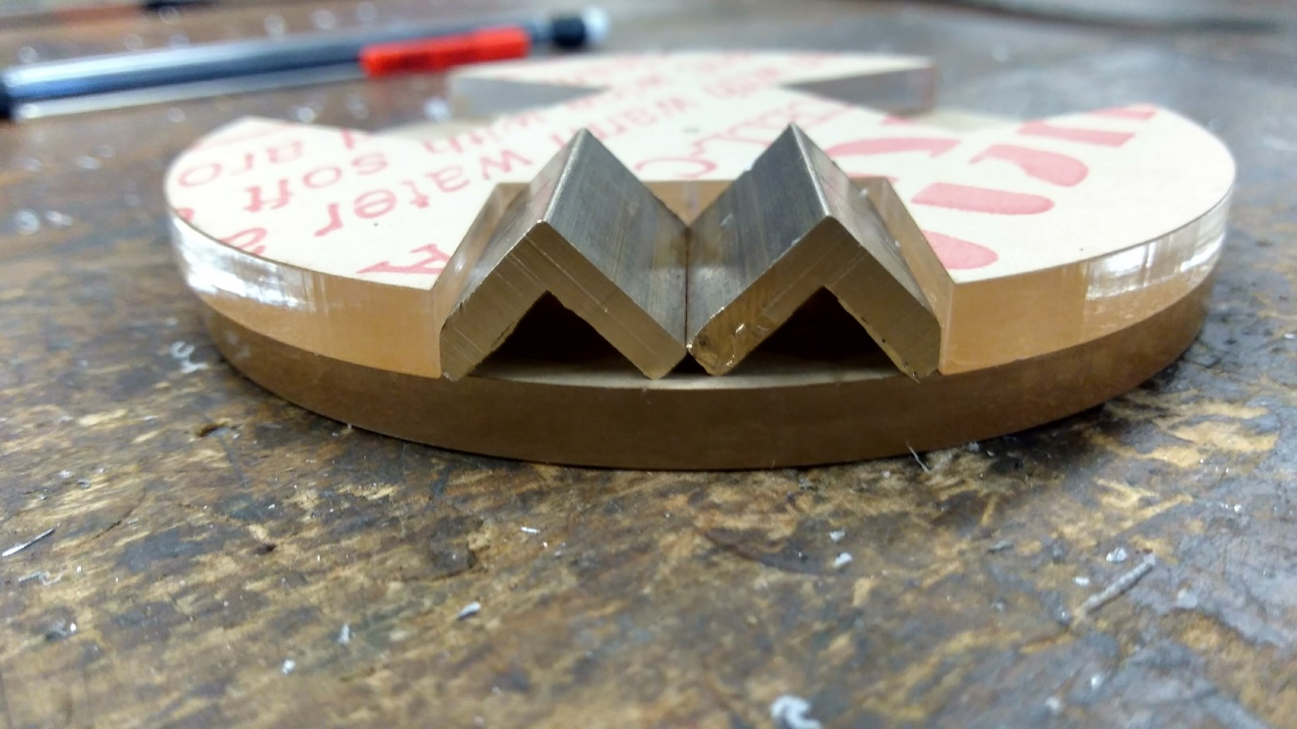
Assembling the grooves within the slots

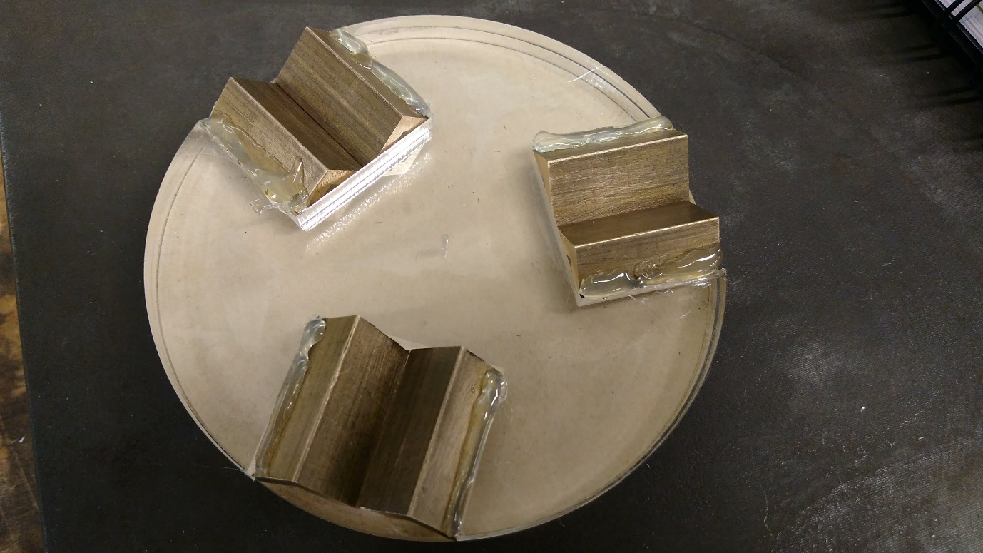
Epoxy Coating on the sides of the grooves

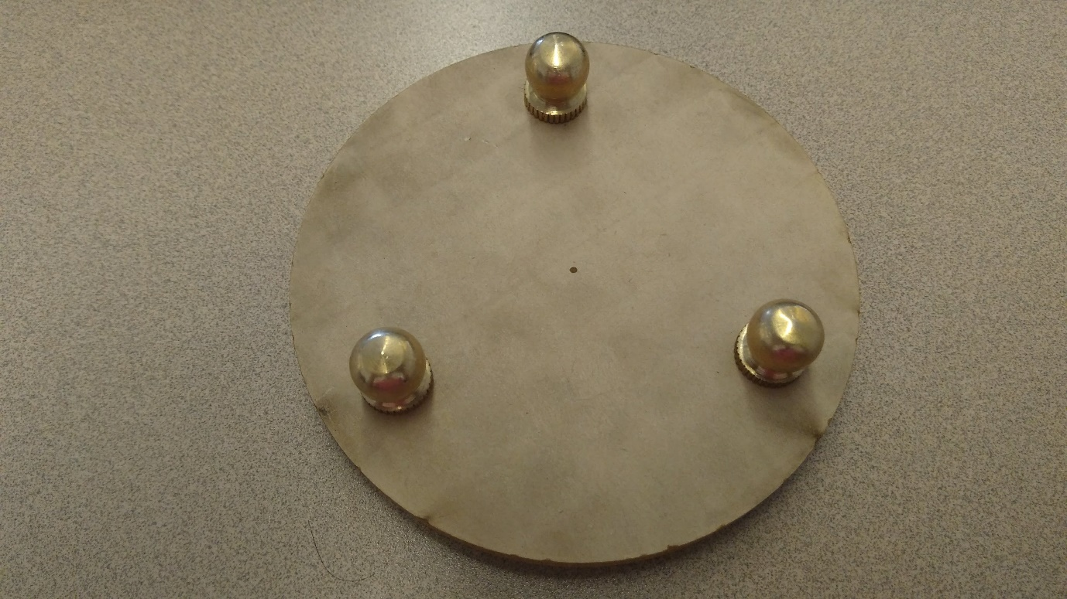
Top Plate (Ball Assembly)

Testing and Quality Control
The kinematic coupling was tested for flatness or angular errors on the top plate. Using the dial gage, I found the variation at 0.02 in which is about 500 um. A laser experiment helped me find the source of error.
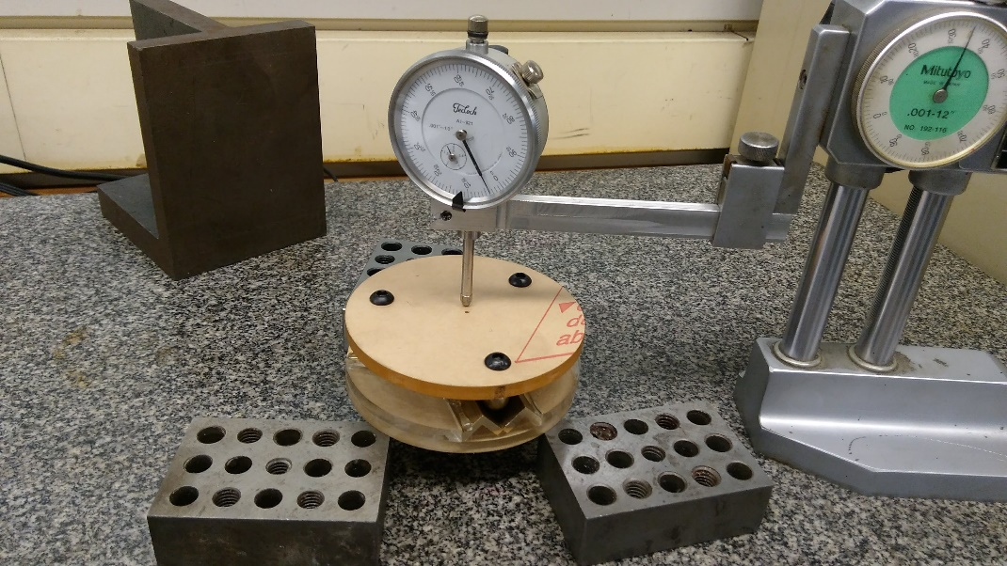
Test Setup for measuring the flatness of the coupling

Using the laser test, I found that something was wrong with one groove ball contact. The error reported on a sheet of paper kept at a distance of 6.3 m was 10.4 cm. This meant an angular deflection of 0.945 degrees. Within the coupling triangle (approximately 6 cm each side), the vertical error was predicted to be 1 mm.
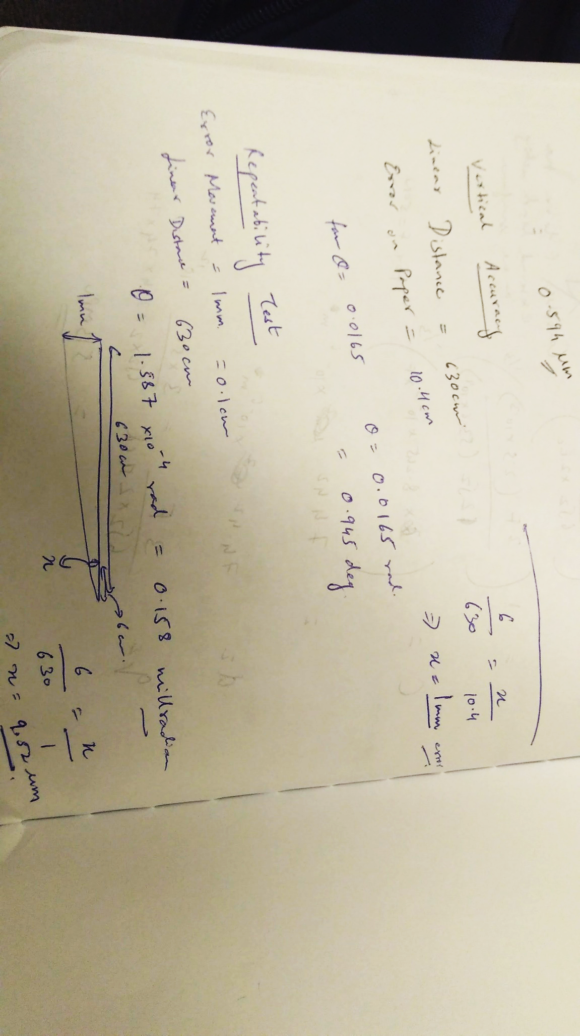
On closer inspection I found that one particular groove insert had lifted up and was no more touching the base as shown in the figure below:
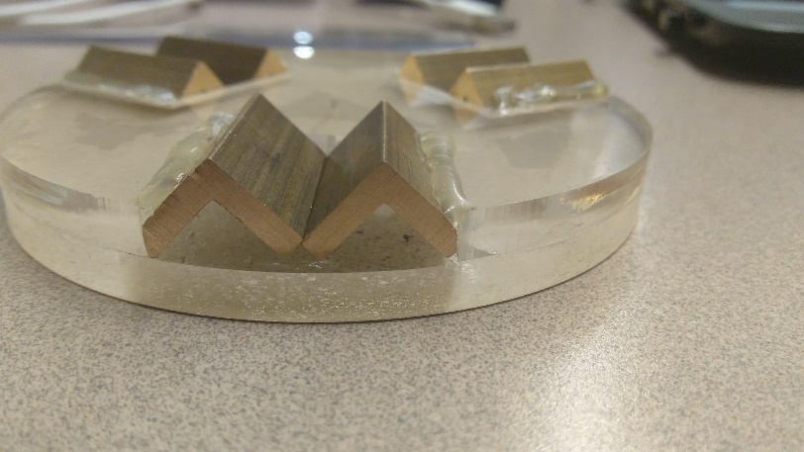
Not touching the base completely
Hence the source of error was identified!
For the repeatability test, I attached a laser on the top plate and observed the change in the motion of the laser pointer each time I lifted the top and put it back again. The maximum movement recorder was 1 mm. This translated to 9.52 um repeatability near the contact points. The repeatability could always be better than this because of many uncertainties in the measurement procedure eg: the movement of the laser with respect to the top plate.
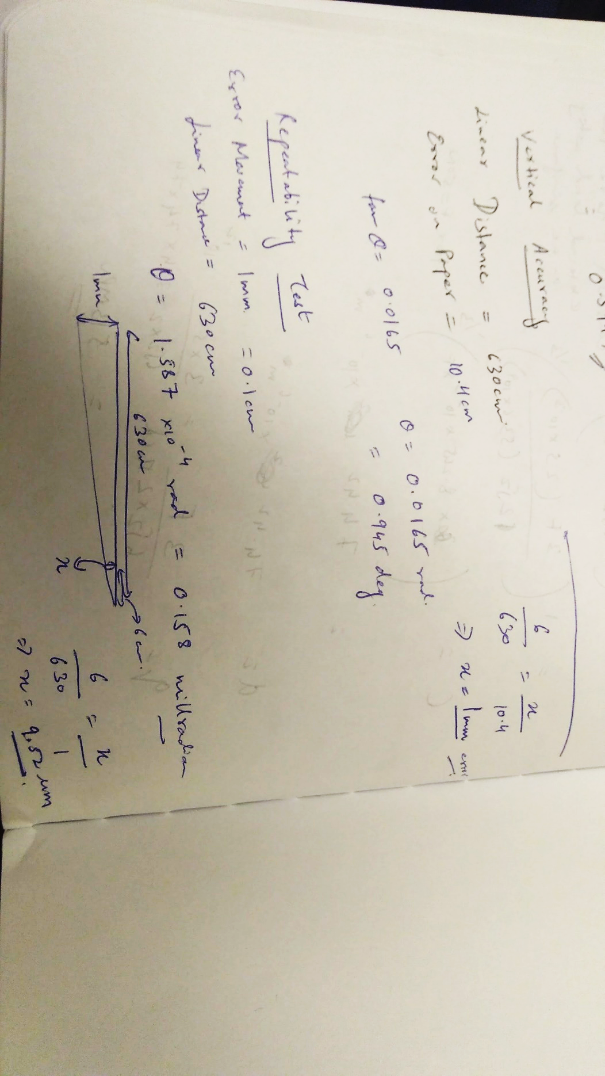
Deflection Test
The deflection of the kinematic coupling was also measured using a dial gage. A weight of approximately 20N was added through the center of the coupling and the resulting deflection at the point 40 mm radially apart was noted. The deflection was 66 um. This was way higher than the predicted deflection which was just 0.594 um. The actual stiffness was 0.303 N/um.
I attributed this deviation to 2 main sources :
a. The deflection of the top acrylic plate itself. I did a quick FEA for this and found that the acrylic plate itself will deflect by about 10 microns
b. The relative movement of the groove inserts with respect to the base plate. Will this one is hard to measure, I did observe a small gap created on the side of the insert due to the addition of epoxy. The load could be pushing the inserts apart, resulting in the additional deflection.
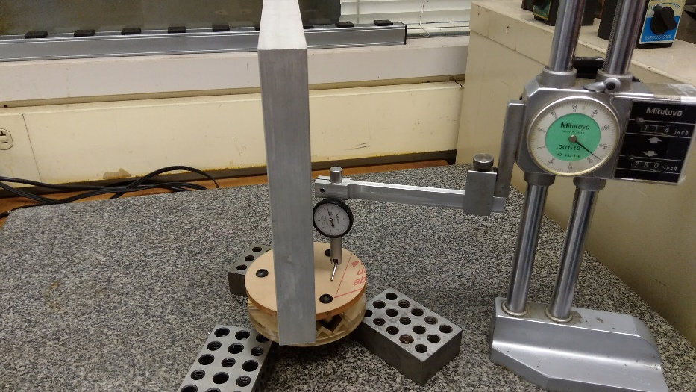
The Deflection Test Setup
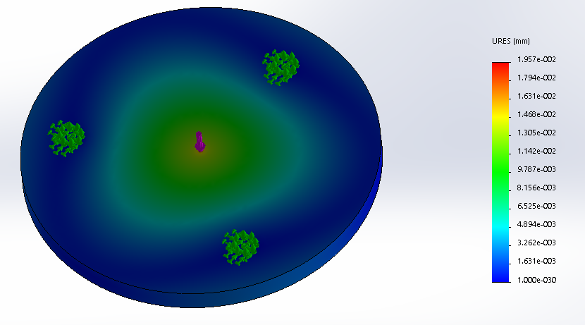
FEA Analysis of the Top Plate Deflection

What could be done better?
1. Having more space between the two groove inserts, so that the inserts do not over constrain each other
Having more space here to avoid over constraints!

2. Ensuring that the edges of the groove inserts lay flat on the base
3. Deburring the edges which contact the sides of the slot so that flush contact can be maintained.
4. Choosing a stiffer material for the top plate

